**Year 8 – Humanities and Social Science, Civics & Citizenship**

**Assessment 5 - Direct Action Research Task**

**Name: _______________________** **Due Date: Week 5, Term 4**

|  |  |  |
| --- | --- | --- |
| **Total marks** | **%** | **Weight** |
| PART A: **/40** |  | 6.0% |
| PART B: **/30** |  | 4.0% |

You are to research a significant protest or social media campaign from Australia’s past. You will then create a protest pamphlet/flyer which explains why you are protesting. This is an individual task.

**PART A: Inquiry Process**

****You must select a group or individual who are or have generated change in Australia.

You must complete:

* A brainstorm on examples of direct action in Australia carried out through public demonstration or social media.
* Focus questions to guide your inquiry
* Note taking sheets
* A bibliography

**PART B: Protest pamphlet/flyer**

After completing your research, you must create a protest pamphlet/flyer that is engaging and explains what you are protesting for or against. Some of this task will be completed in class with allotted computer lessons, however, it is the responsibility of the student to utilise their time both in class and at home.

Your protest pamphlet/flyer must include the following:

* Have a creative design
* 400-500 words
* A brief analysis of your chosen issue and the change you want (your message)
* An explanation of how people can use campaigns to influence change
* Why you chose to use these particular campaigning methods/s

**PART A**: Inquiry Booklet

1. **Brainstorm 4 marks**

Use the box provided below to brainstorm examples of direct action in Australia. This should help you determine which protest, or public demonstration, or social campaign you can base your research on. If you cannot think of many public demonstrations, take some time to do some internet/ library research before completing your brainstorm.

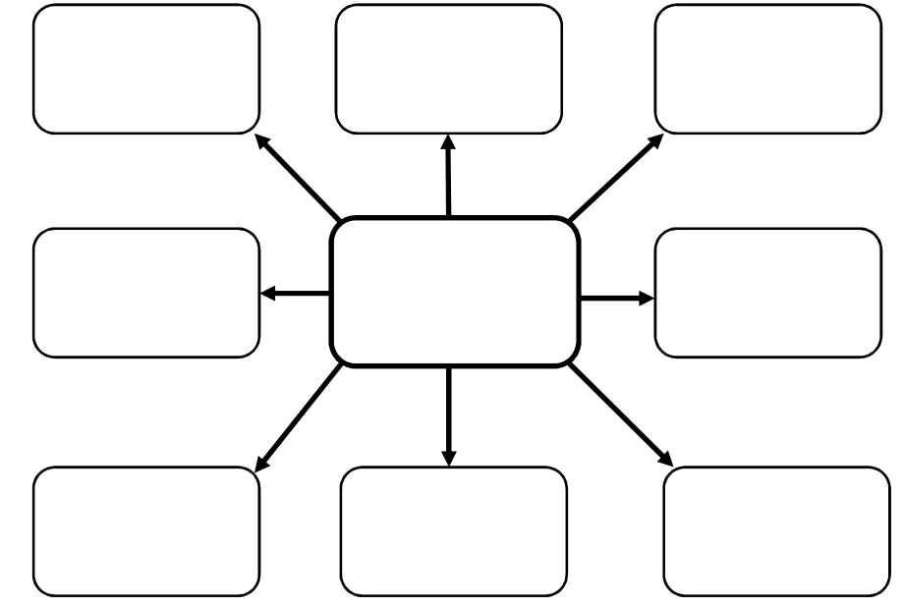

1. **Focus Questions Total: 12 mark**

Take each dot point: convert it into a specific question **(1 mark);** include details relating to your chosen public demonstration or public campaign **(1 mark)**, i.e. ‘*What is the background of the groups, or individuals, who were directly connected to the anti-war protests during the Vietnam War era of the 1960s and 1970s?*

List each of your focus questions separately at the top of each note taking page overleaf. You are expected to devise your own focus question for the sixth and last note taking sheet.

Your research must:

* Include the background of the selected group or individual
* Discuss the issue of the selected group or individual- why were they campaigning?
* List the methods used by your group or individual-social campaigning
* Effectiveness of your selected group/individual in bringing about change
* Discuss how your selected group/individuals are participating in Australia’s democracy

1. **Note taking Total:18 marks**

Recording key pieces of information that directly relate to your research is essential. Keeping that information in easily located places is equally essential. This allows you to quickly find and access what you are looking for at each stage of your project.

Use the note taking sheets overleaf to place your newly found information under the focus questions you have set yourself - so the information that you find that answers each of your focus questions, must be recoding under that focus question on its own note taking sheet.  
  
You may earn up to three marks for each set of notes you create.

The notes must be: of a volume that indicates you have done a thorough investigation and looked at numerous sources **(1 mark)**; your notes must appear as if you are organising this information in a logical and ordered manner that allows you to use them effectively later on **(1 mark)**; your notes must include information that effectively addresses the set focus question **(1 mark)**.

**Notetaking: use the focus questions to find information about significant individual.** Add paper if required.

|  |  |
| --- | --- |
| Focus question 1: | Focus question 2: |
|  |  |

|  |  |
| --- | --- |
| Focus question 3: | Focus question 4: |
|  |  |

|  |  |
| --- | --- |
| Focus question 5: | Focus question 6: |
|  |  |

**Reflection**   **(6 marks)**

Please respond to the following four questions (*be specific)*:

I learnt …

|  |
| --- |
|  |
|  |
|  |
|  |
|  |
|  |

I was surprised …

|  |
| --- |
|  |
|  |
|  |
|  |
|  |
|  |

I wonder …

|  |
| --- |
|  |
|  |
|  |
|  |
|  |
|  |

**Bibliography – to be submitted with your Protest Pamphlet**

*Bibliography – a list of all the source you have referred to throughout your inquiry.*

You need to create a correctly formatted bibliography for any inquiry that you do. Record all the details of every source you access in your bibliography.

The rule is – **if you SIGHT it – CITE it!**

*Plagiarism – the practice of taking someone else’s work or ideas and passing them off as one’s own***.**

Narrogin Senior High School has a ZERO TOLERANCE POLICY regarding plagiarism.

**citethisforme.com** is a usual website for compiling references**.**

**Books**

**Example**: Arends, K. Humanities & Social Sciences 8, Pearson, 2017.

|  |  |  |  |  |
| --- | --- | --- | --- | --- |
| Author’s Surname | Author’s First name | (Year Published) | *Book Title (in Italics)* | Place of Publication: Book Publisher. |
| , | . | . | . | . |

**Websites**

**Example:** Cowley, R. Saladin, from the Readers Companion to Military History, 1996, <https://www.history.com/topics/saladin>, accessed 31/7/18

|  |  |  |  |  |  |
| --- | --- | --- | --- | --- | --- |
| Author’s Surname | Author’s First name | (Year Published) | *Website Title (In Italics)* | Website URL | Date you used the website. |
| , | . | . | . | . | Accessed: |

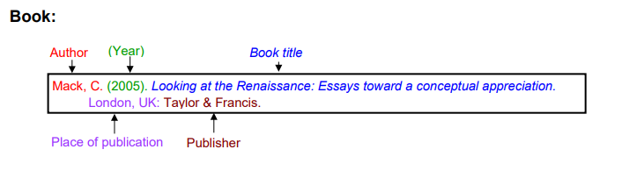Once you have created your reference, all references are organised on a new page in ALPHABETICAL order by the author’s surname.

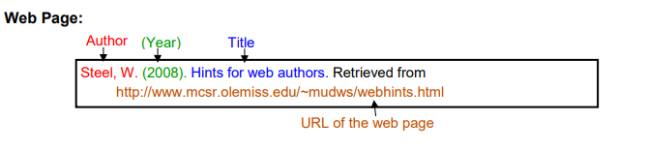

** Marking rubric: PART B Pamphlet/Flyer**

**Name:____________________________________ Teacher: _________________________________________**

|  |  |  |  |  |
| --- | --- | --- | --- | --- |
| **Pamphlet/Flyer** | **0 - 1** | **2 - 3** | **4 - 5** | **Subtotal** |
| Creativity | Campaign does not include creativity or persuasive language to influence Parliament or affect any social change | Campaign includes some creativity and persuasive language which could influence Parliament or affect social change | Campaign includes outstanding creativity and very persuasive language which could influence Parliament or significantly affect social change. | **/5** |
| Understanding of issue | Does not demonstrate an understanding of the chosen issue | Demonstrates a good understanding of the chosen issue | Demonstrates an excellent understanding of the chosen issue | **/5** |
| How citizens can participate in Australia’s democracy to influence change | Does not provide an adequate analysis of how citizens can participate in Australia’s democracy to influence change | Provides a sound analysis of how citizens can participate in Australia’s democracy to influence change | Provides an excellent and thorough analysis of how citizens can participate in Australia’s democracy to influence change | **/5** |
| Explanation of choice of campaign method/s | Does not deliver an adequate explanation of choice of method/s used or show an adequate understanding of how citizens can participate in Australia’s democracy to influence change | Delivers a solid explanation of choice of method/s used showing sound understanding of how citizens can participate in Australia’s democracy to influence change | Delivers a reasoned, logical explanation of choice of method/s used showing excellent understanding of how citizens can participate in Australia’s democracy to influence change | **/5** |
| Work Effort | Limited working productively and utilised time management skills | Somewhat worked productively and utilised time management skills | Worked productively and utilised time management skills | **/5** |
| Bibliography | No bibliography submitted (0)  Bibliography includes a limited list of sources which may follow the referencing technique approved by the school, however, does not incorporate all requirements. | Bibliography includes a smaller range of sources which mostly follows the referencing technique approved by the school. | Collects information and images from a comprehensive number of sources and records a variety of key information which relates to the chosen significant individual, incorporating ethical protocols, which correctly follow the referencing technique approved by the school. | **/5** |
| **TOTAL** | | | | **/30** |

**Overall comment:**

What you did well…

*__________________________________________________________________________________________________________________________________________________________________________________________________________________________________________________________*

The best part was…

*__________________________________________________________________________________________________________________________________________________________________________________________________________________________________________________________*

Even better if…

*__________________________________________________________________________________________________________________________________________________________________________________________________________________________________________________________*